**Atul Anurag**

**PES2UG19CS075**

**COMPUTER NETWORKS LAB**

**Week 9**

**Understand the building blocks and usage of ClayNet Network Virtualization platform with reference to OSI Layer.**

**Objectives of the Lab:**

* Understand the building blocks of ClayNet.
* Build a simple client-server network using routers, switches, and network hosts.
* To learn the static IP routing behaviour such as default and static routes and routing tables.
* Use common network utilities to verify LAN operation and analyse data traffic.

**Prerequisites:**

This lab assumes some understanding of the building blocks of communication networks and basic client-server architecture.

**Topology 1:**

Create a topology in ClayNet, as shown in following figure.

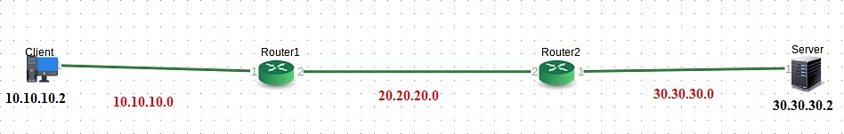

**Important Instructions:**

To access ClayNet, type **http://1.6.180.226:9000/** in browser**.** Login credentials will be provided by the faculty in charge.

**Execution Tasks:**

**Task 1:** Understand the network and compute components available in ClayNet.

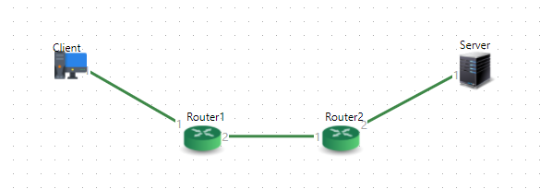

**Task 2:** Drag and drop thenecessary components to create the given topology. Provide the names for compute, select OS (Ubuntu 16.04 – Lite or Ubuntu 16.04 – CLI) and RAM (512 MB) as shown below.

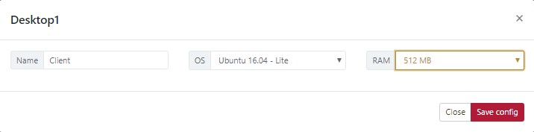

**Task 3:** Drag and drop the Routers andset the IP addresses for all the necessary router ports.

(You can also set them later by right clicking on the router icon and selecting ‘Device Configuration’.)

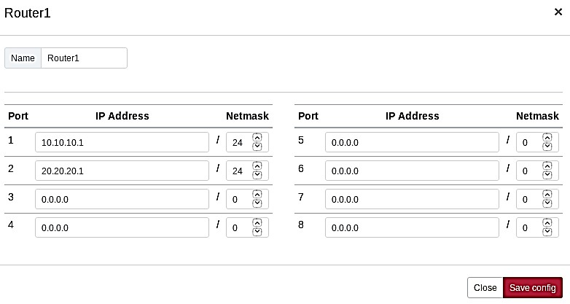

**Task 4:** Go to connection manager and select appropriate Source, Source ports, Target and Target ports and save the connection.

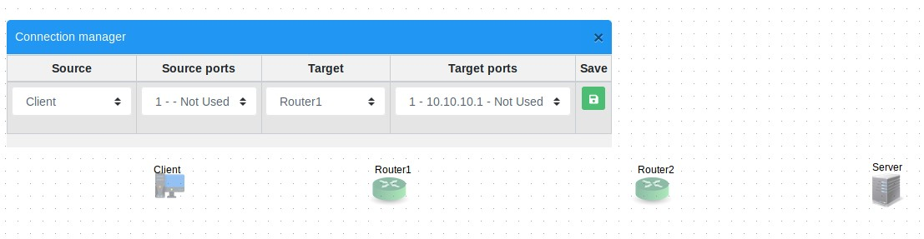

**Task 5:** To deploy the topology, save the topology first and deploy it by clicking ‘Deploy’ button available on the top. (Note: It will take few seconds or even minutes to deploy the topology for the first time).

**Task 6:** Go to ‘Remote Desktop’ by right clicking on client and server icons and set the IP addresses accordingly. Also add the gateway address. (Login: user - test, password - test)

**Client:**

IP Address ---> 10.10.10.2 Gateway ---> 10.10.10.1

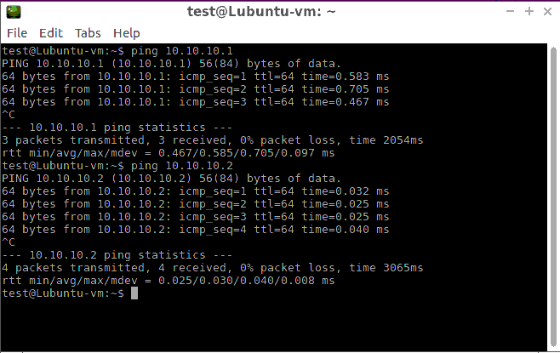

**Server:**

IP Address ---> 30.30.30.2 Gateway ---> 30.30.30.1

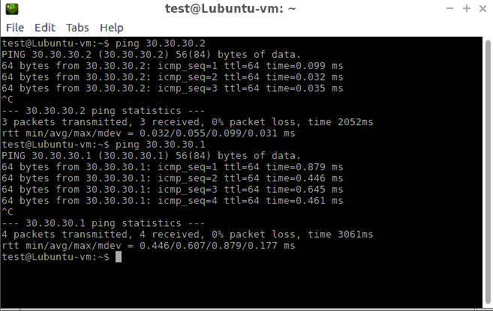

**Task 6:** From client, ping to server 30.30.30.2. Ping will not be successful and Router1 will reply with ‘Destination host unreachable’. 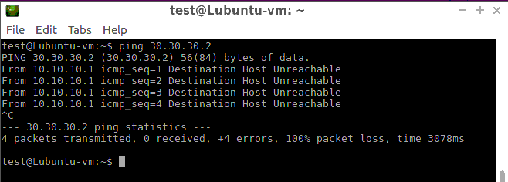

**Task 7:** Set upthe following routing table entries for Routers 1 & 2.

|  |  |  |  |  |
| --- | --- | --- | --- | --- |
| **Routers** | **Destination** | **Next hop gateway** |  | **Via** |
| Router 1 | 30.30.30.0 | 20.20.20.2 | Direct |  |
| Router 2 | 10.10.10.0 | 20.20.20.1 | Direct |  |

**Steps to add the routing table entries:**

**Step 1:** Login to Router1 by right clicking on Router icon and selecting ‘Console Access’. (Type

‘Enter’ key once to get into Login screen. Username - test, Password- test@12345) **Step 2:** Display the routing table to view all static routes using the command.

**show route summary -s active data**

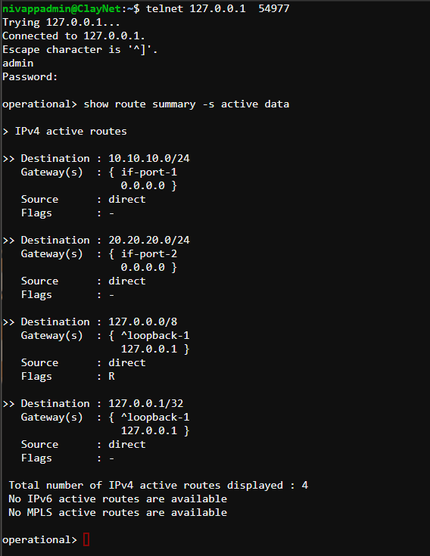

Note in routing table of Router1 that there is no route to reach the destination network

30.30.30.0/24. Go to configure mode and start configuring the router for all the possible routes.

**Step 3:** Configure a static route in Router1 for destination 30.30.30.0/24 with next-hop gateway as 20.20.20.2, which is the IP address of Router2.

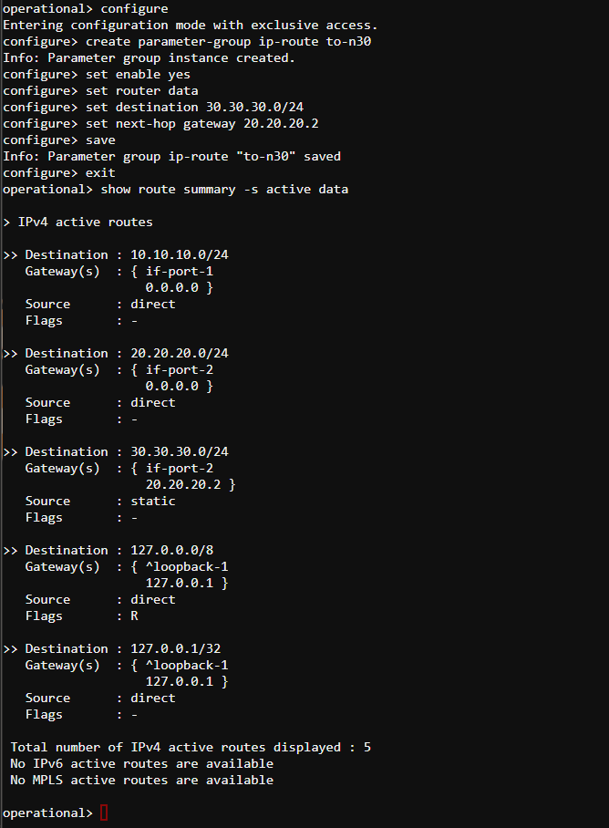

**Step 4:** Check routing table again and verify that the route is added.

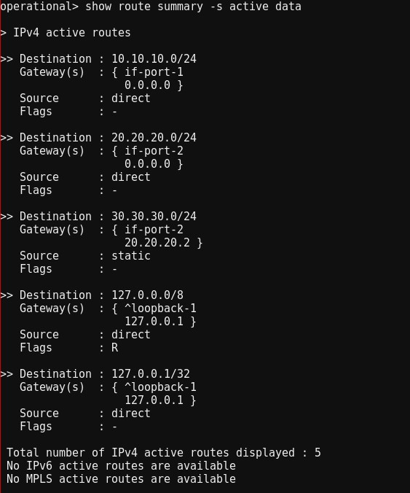

**Step 5:** Repeat the steps 3 & 4 to configure a static route in Router2 for destination

10.10.10.0/24 with next-hop gateway as 20.20.20.1, which is the IP address of Router1.

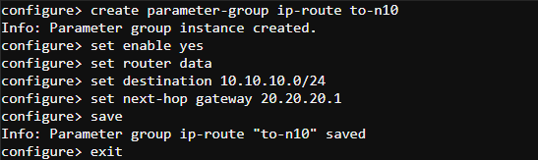

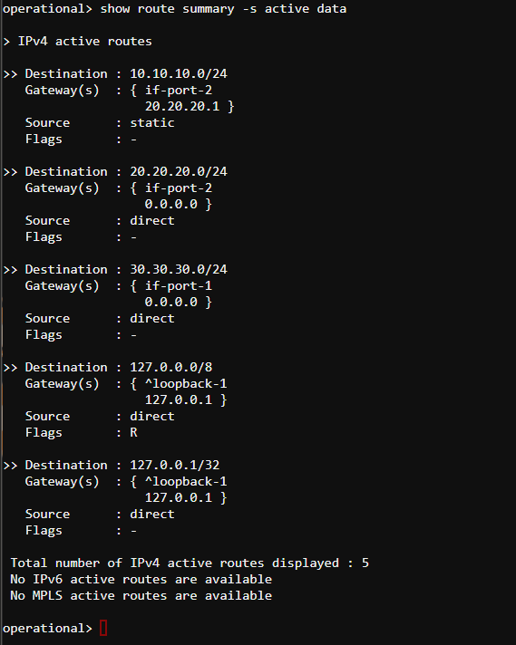

**Task 8:** Now Ping will be successful as all the required routers are now configured. Observe the TTL getting decremented by 2 because two hops/routers are in between. Also keep the Wireshark ready for observation.

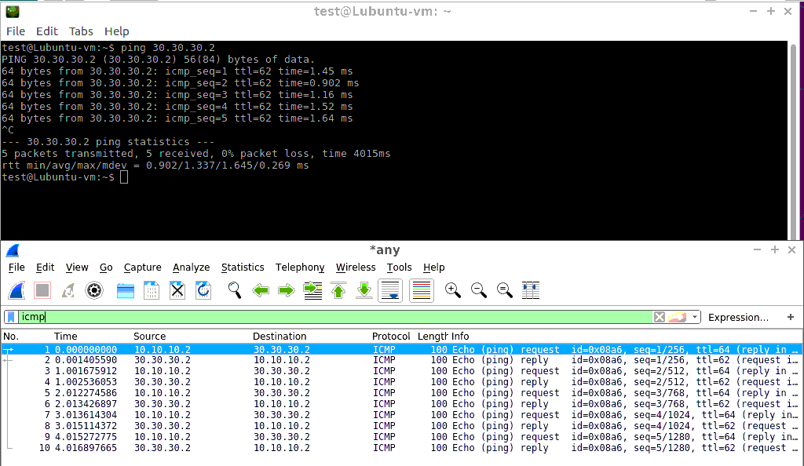

**Task 9:** Also observe the output of **tracepath -n 30.30.30.2** command on Client.

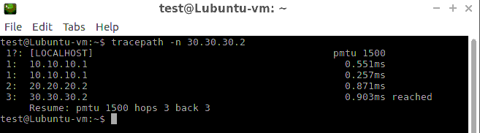

**Observations:**

How many hops will client take to reach the serve? - 3 hops

Observe the RTT **-** The RTT is 2.582 ms